SHORT WEEK, University of Gävle 6-10th of March 2023.
PRE AND PRIMARY SCHOOL CULTURE IN A NEW CONTEXT WHEN EDUCATION IS CHALLENGED BY MIGRANTS – working with migrant pupils and meeting newly migrated parents/legal guardians

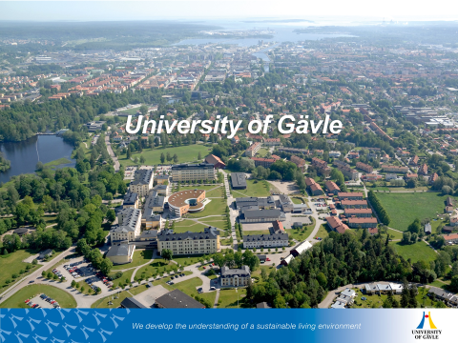
www.hig.se www.visitgavle.se

Welcome to our international Short week
The University of Gävle, Sweden, is most pleased to welcome you to our short exchange week from March 6th at 14.00 until March 10th at 12.00, 2023. We are very much looking forward to fruitful discussions and exchange of experiences within the theme of this short exchange “Pre- and Primary School Culture in a New Context – working with migrant pupils and meeting newly migrated parents/legal guardians. When Education Is Challenged By “Immigrants”. In times of war, not so far from our countries, for the moment many Ukraine migrated children and their parents arrive to our countries in Europe.

The Short Exchange week focus on the work we are trying to fulfill, to include migrant pupils and their parents in our schools – aligned with the “The Convention on the Rights of the Child” (1989), “The Salamanca Statement on special needs education” (1994) and our national curriculum. In ‘the European family’ we all have experienced, experience and will experience encounters as results of developments in other countries and nations. As responsible for education and schooling, our task has become more complex due to this change. A question we, aligned with the Rights of the Child, The Salamanca Statement, and the national curricula, is how the work during the Short Week can contribute to your professional work in the field studied. How can you adapt the knowing from our days focusing this issue, to the task waiting for you when you enter preschool or school as a well-prepared teacher?

In the week we work with different topics according to the challenge, how to work with pupils, how to understand parents’ perspectives, visit one multicultural school and visit Rapatac (organization that work with migrant children to support them after school activities and homework). How is it to work and support migrant children in the classroom. How it is to integrate to a new school context.
In ‘the European family’ we all have experienced, experience and will experience encounters as results of developments in other countries and nations. As responsible for education and schooling, our task has become more complex due to this change. We also work from three interesting project about migrants’ pupils, parents, and teacher mentors at school (Framtid Studiehandledare, ENABLE and PARENTable).

Some General Information
We start at the University of Gävle at 14:00 on Monday March 6th (open from 13.30) and will be closing on Friday March 10th at 12:00. Program will be sent out the week before.

Food
During your stay you have the breakfast at the hotel (including the price) and lunch at campus (lunches including the price), one evening a light evening meal for free before the evening activity and finally a Swedish fika.
The Swedish fika; https://www.youtube.com/watch?v=oRIeytEXGhQ

Accommodation
Will be at a hotel in Twin rooms (including breakfast)

Fee/Payment
There is a fee of 150 Euro for hotel and other costs that has to be payed to the University of Gävle no later than February 28th 2023. If you are staying more nights, we have decided that you pay for that night/nights directly to the hotel.

ECTS credits
The week gives you 2 ECTS credits, you do a short preparation from your experience before your arrival.

Nomination: Our nomination period for the Shortweek 2023 is now opened and nomination can be sent in from your university not later than December 15, 2022. Once the nominations have been received, we will send e-mails to you as a student with instructions on how to apply online. In the online application it is important that you attach their filled in form “application for short week”, a copy of your passport and our Exchange Student Form.
Program: Program and practical information about the week will be sent out in the beginning of January.
Our warmest welcome! Regards Kia Kimhag Contact: Kia.kimhag@hig.se

