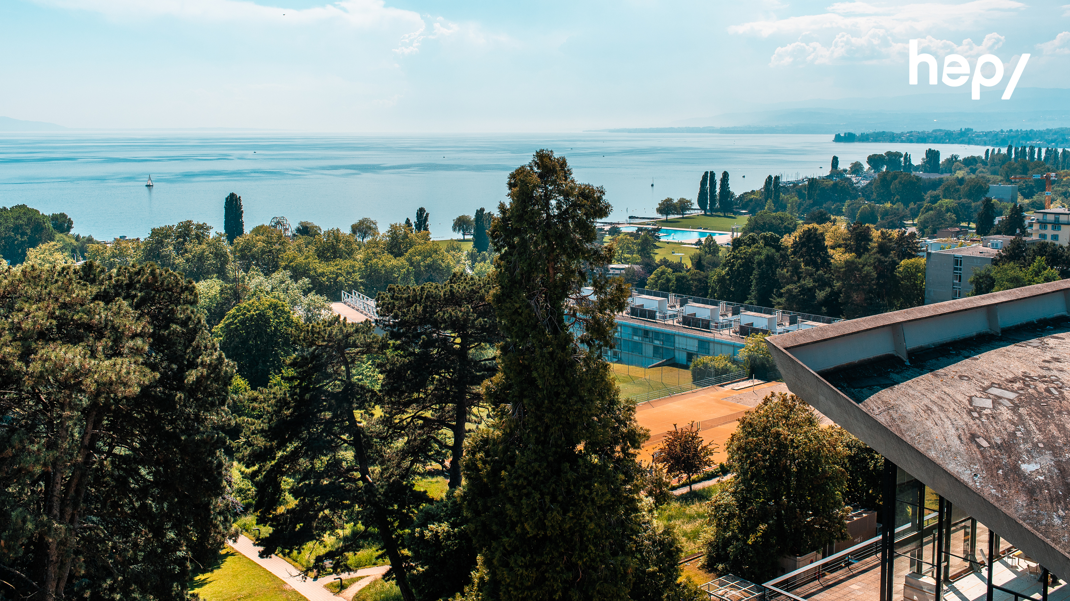

Studying at the HEP Vaud means learning in Lausanne, in an outstanding and unique setting close to Lake Geneva and the Swiss Alps, while discovering new teaching approaches and practices in a human-scale institution where there are many opportunities for collaboration. Each semester, we welcome students from Europe and Canada.

We train teachers and offer Bachelor and Master level courses to teach pupils of primary and secondary levels as well as courses to train as a specialist teacher. Our star feature is the possibility to have a tailor-made individual study programme. We also offer a teaching experience opportunity in a public school which allows you to combine theory and practice.

Teaching at the HEP Vaud is conducted in French, however, an English-speaking programme combined with French language classes is available.

